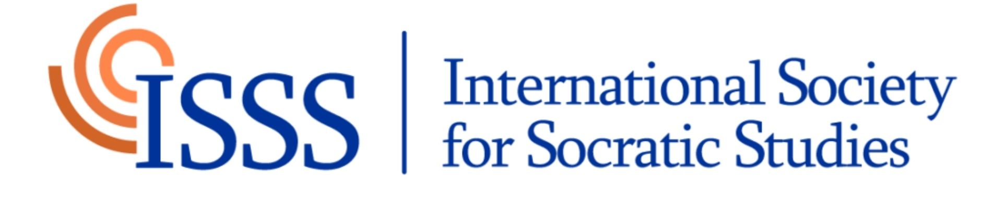

Membership application form

Please note that this form may be completed in any of the Society's official languages (English, French, German, Italian, Portuguese, Spanish).

Full name:

Email:

Academic affiliation:

Please paste a brief CV (1-2 page) that demonstrates the connection between your work (broadly defined) and Socratic studies. A complete CV is not necessary; simply highlight your research, publications, courses taught, or interests related to Socratic studies.

